How to setup bioollect in Intellij

- Clone biocollect grails 3 project into a directory.
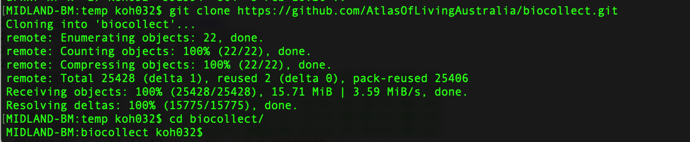

- Checkout the branch which contain the latest grails3 code.
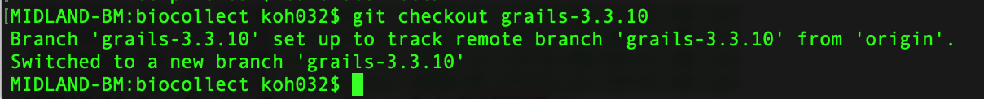

- In Intellij, click Open and navigate to the biocollect folder then click on Open.
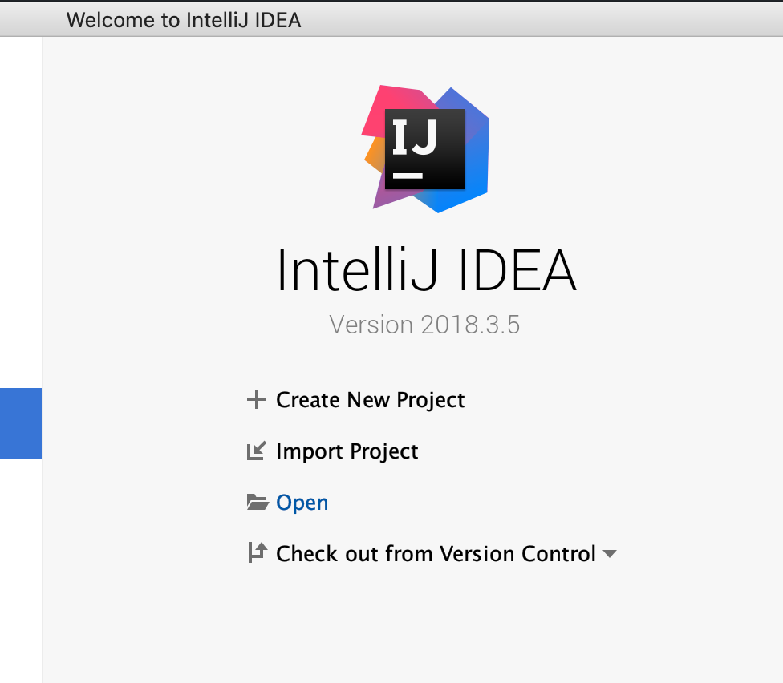

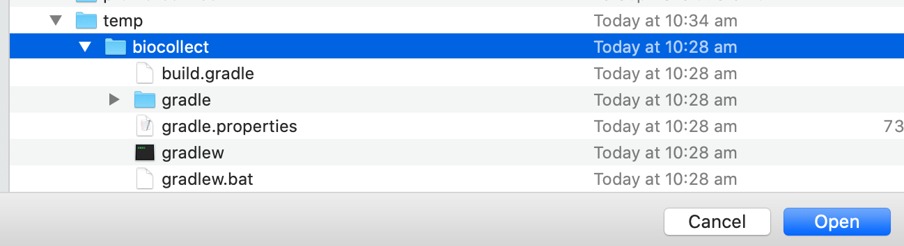

- The first time when you open the project, you need to Import Project from Gradle. As the biocollect project comes with Gradle wrapper, keep the default setting and click OK.

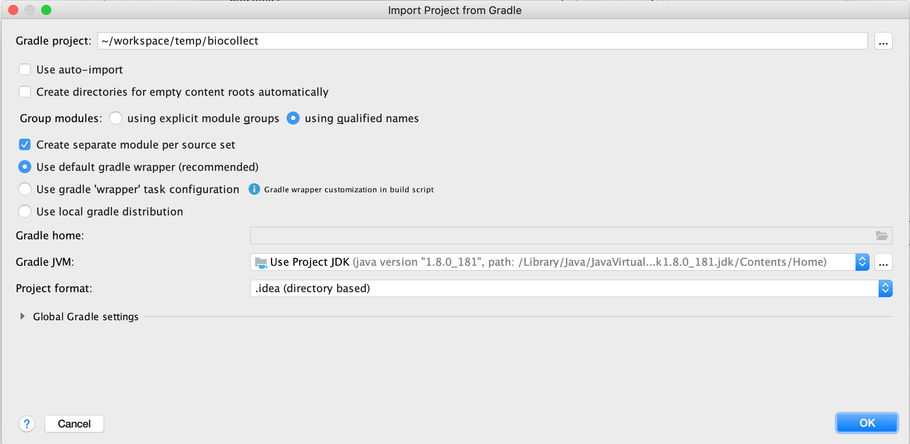
- Once the project opens, wait for Intellij to configure the build. You should see the following.

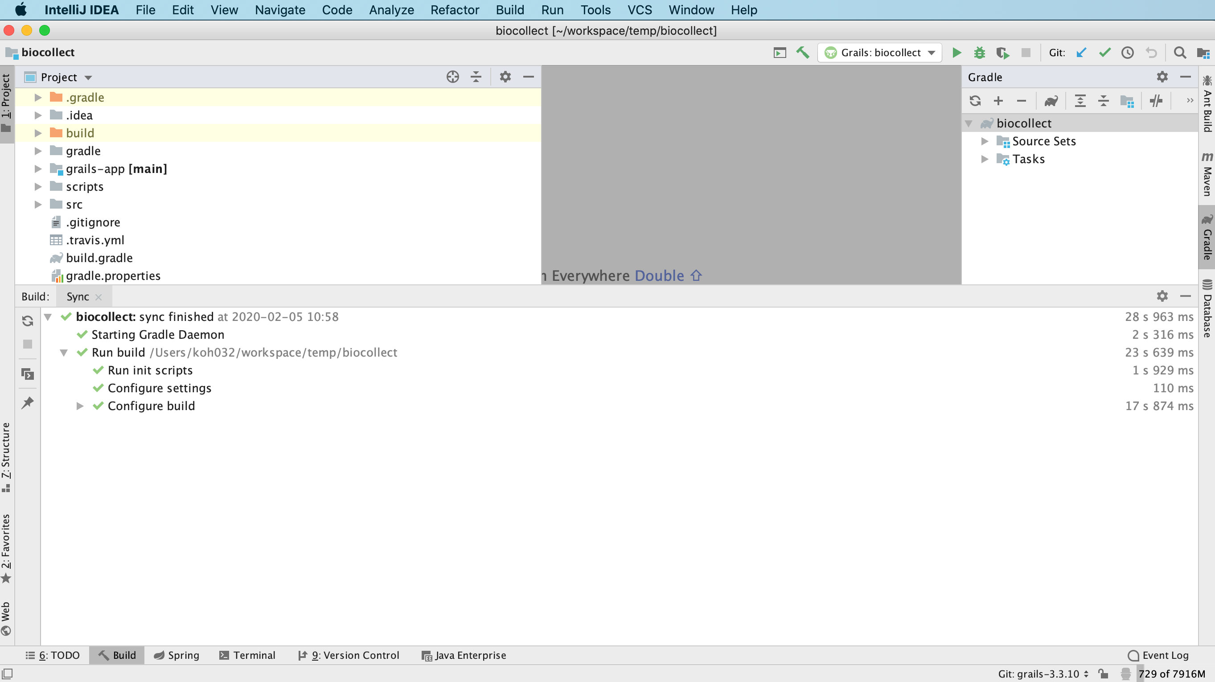

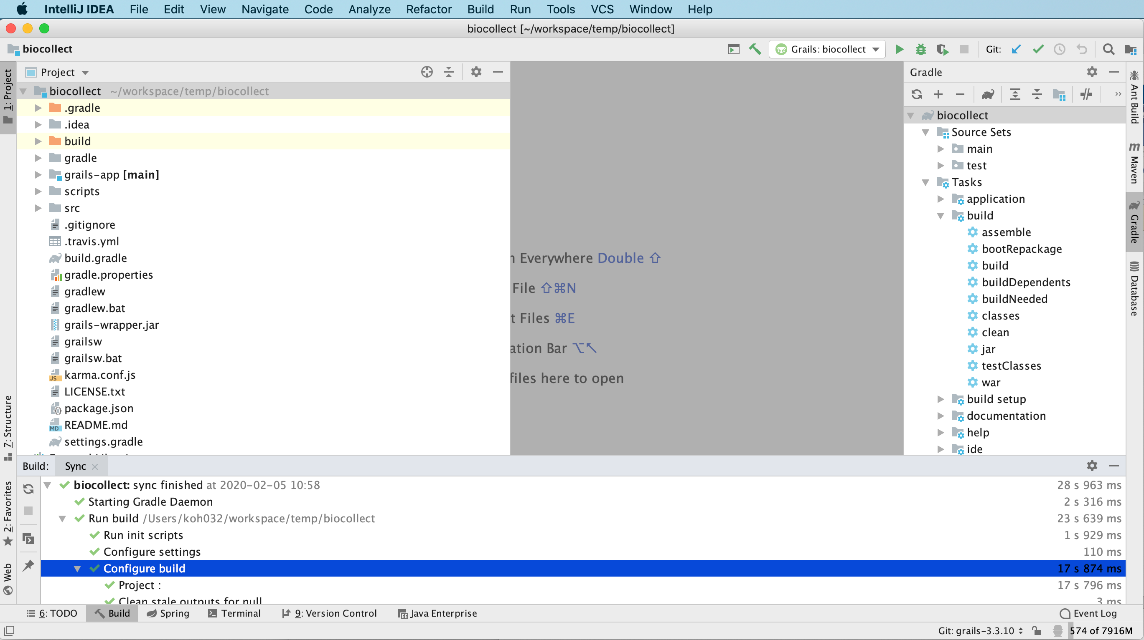

- Before running biocollect grails 3, make sure that the following properties file exist in /data/biocollect/config/biocollect-config-grails3.properties

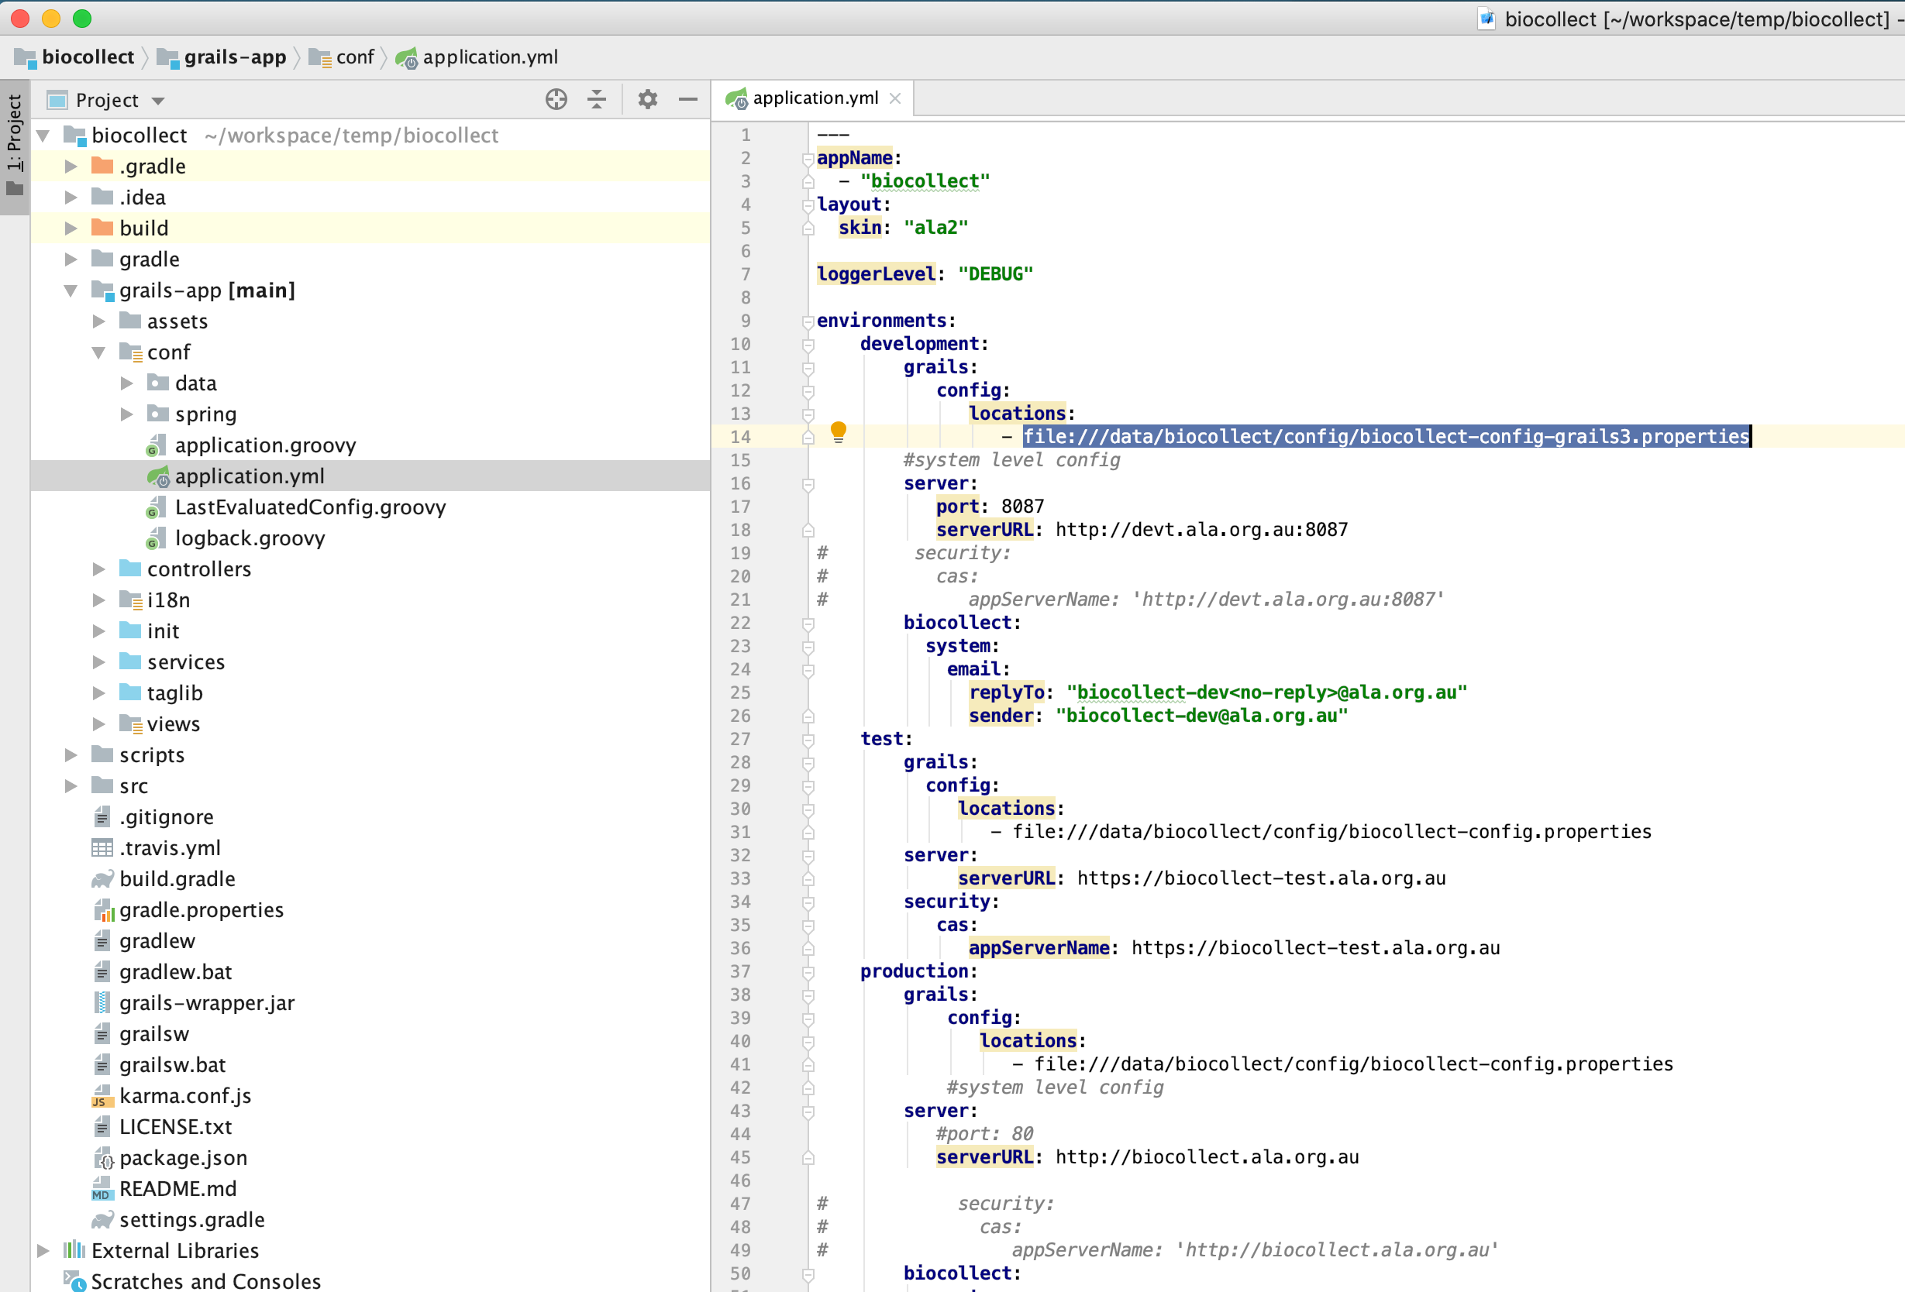

The minimum config in the properties file looks like this:

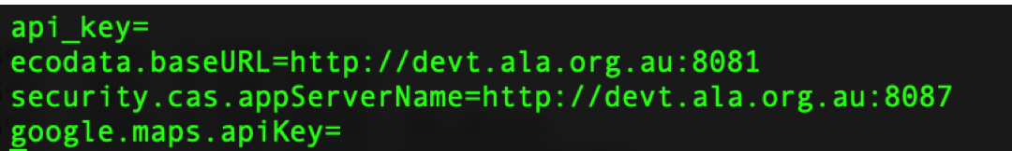

How to modify plugins in a grails 3 project

- To modify a plugin project for biocollect, for eg: ala-map-plugin, first git clone ala-map-plugin in the same folder where biocollect is. Checkout branch grailss3.

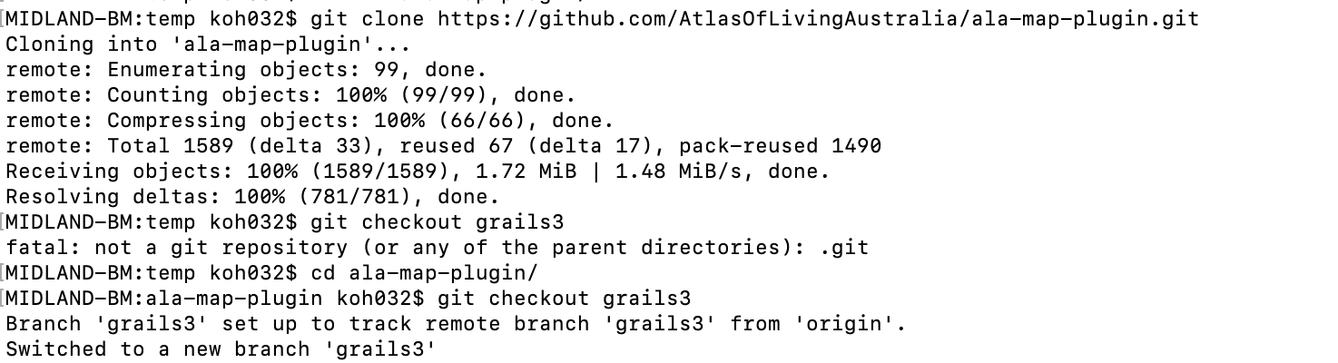

- In biocollect project, modify settings.gradle and add the following:
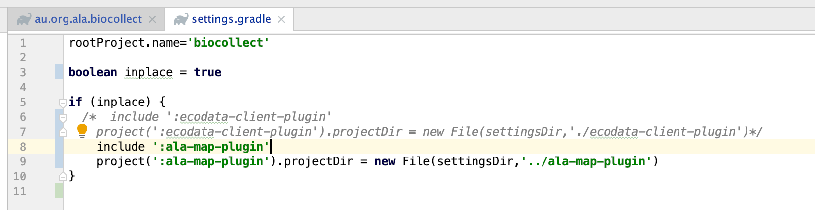

- In biocollect project, modify the build.gradle file to set inplace = true, then add the inplace plugin
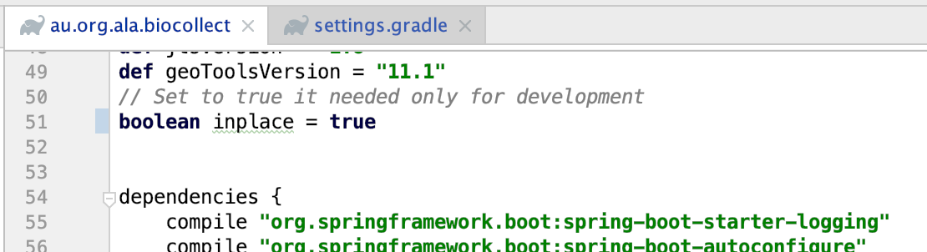

Make sure dependencies does not include the ala-map-plugin as we have inplace plugin project which is part of the build.

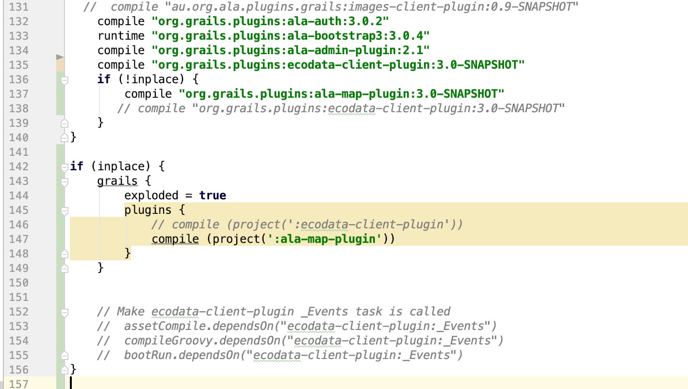

- Once the build.gradle is modified, rebuild biocollect project. Once the project has a successful build, you should now see ala-map-plugin project as well.

